**Braincorp Exercise Documentation**

***Built With:***

I ) Visual studio – c# web api

***Version:***

Ver 1.0 ( prototype)

***Getting started :***

Open the solution file with visual studio 2017 ( pref.) and run with IIS express for any browser . Default path for user file : c:\etc\passwd.txt

Default path for group files: c:\etc\groups.txt

All inputs are provided through the URI.

***Changing Paths :***

Paths to each file can be changed by using the URI and specifying /setpath? For either user or groups

Example:



if the file does not exist ,throw a 404 error

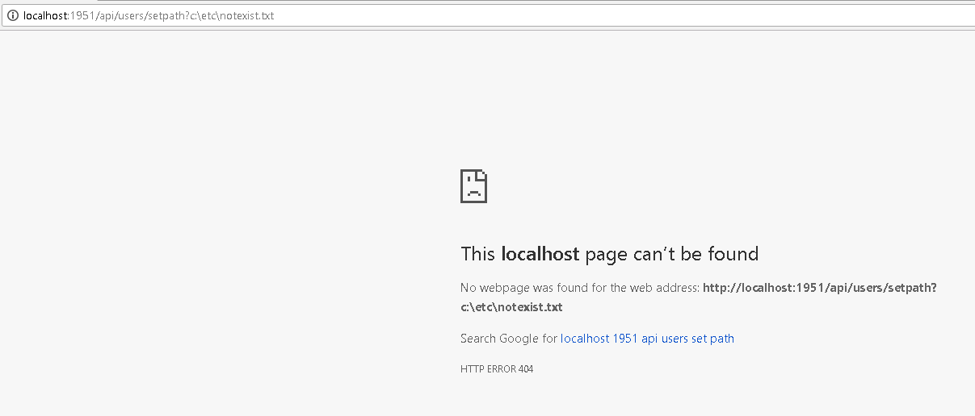

For groups , we use the same syntax but use the /groups route.



Throw exception is no path exists.

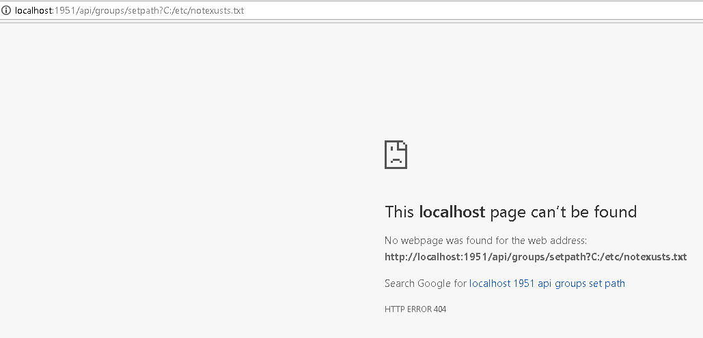

***Using the service:***

1 ) Get Users : Returns all users

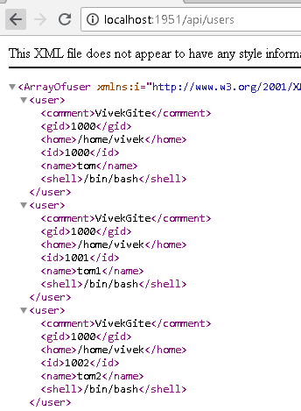

2) Get users by query : Returns users by query , one for more can be provided .

User with id and name queries

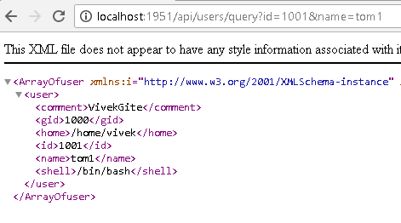

User with only Id queried :

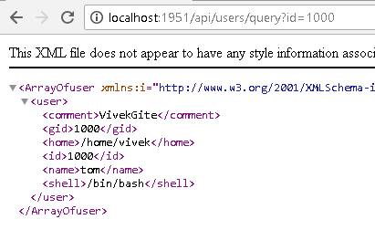

User with id gid and name queried

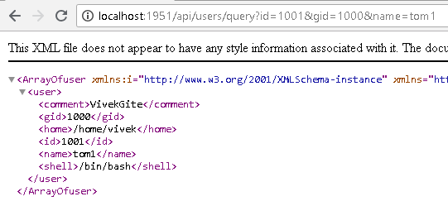

3) Get single user by id :

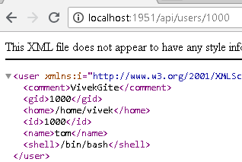

4) get all groups for a single user

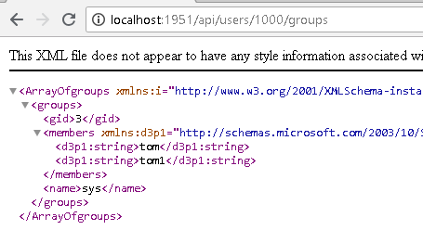

5) Display all groups

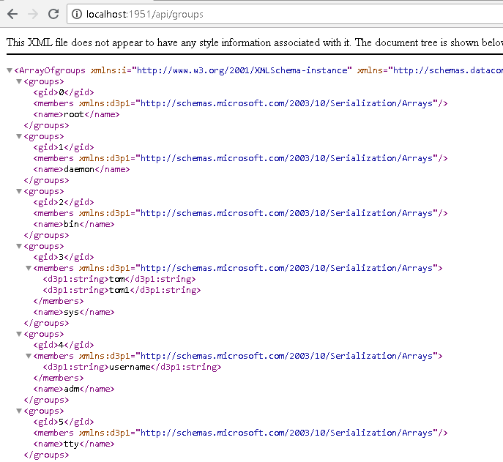

6) Display groups by query

Group queried for one memeber

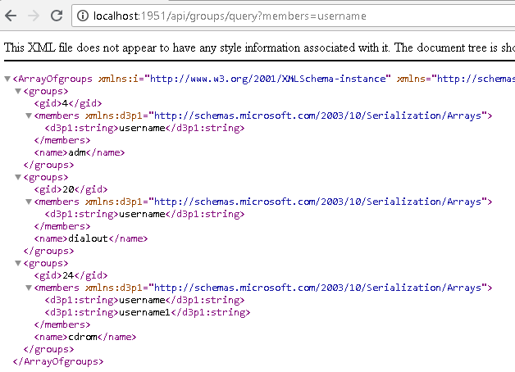

***Group queried for gid***

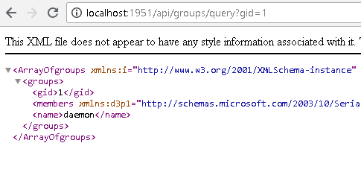

***7 ) group/<gid> : returns group with specific id***

